VLSI DESIGN AND AUTOMATION SUMMER INTERNSHIP
WEEK 3 SUBMISSION
RESOURCE : WEEK 3 ( ENC and NETLIST files are here )
FSM ( Finite State Machine ) – Sequence Detector 1011
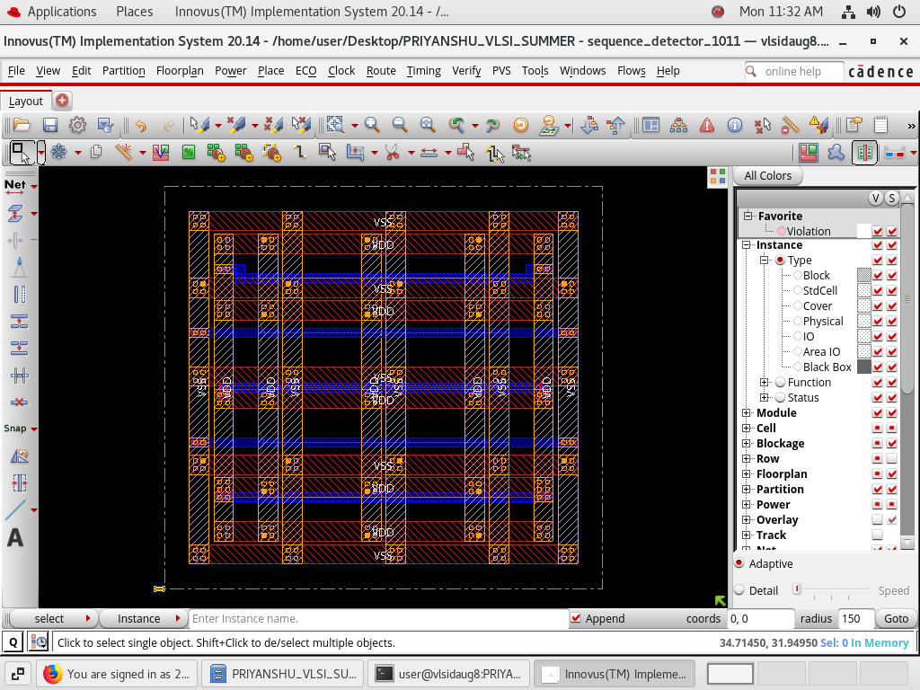

Combination Circuit – Full Adder
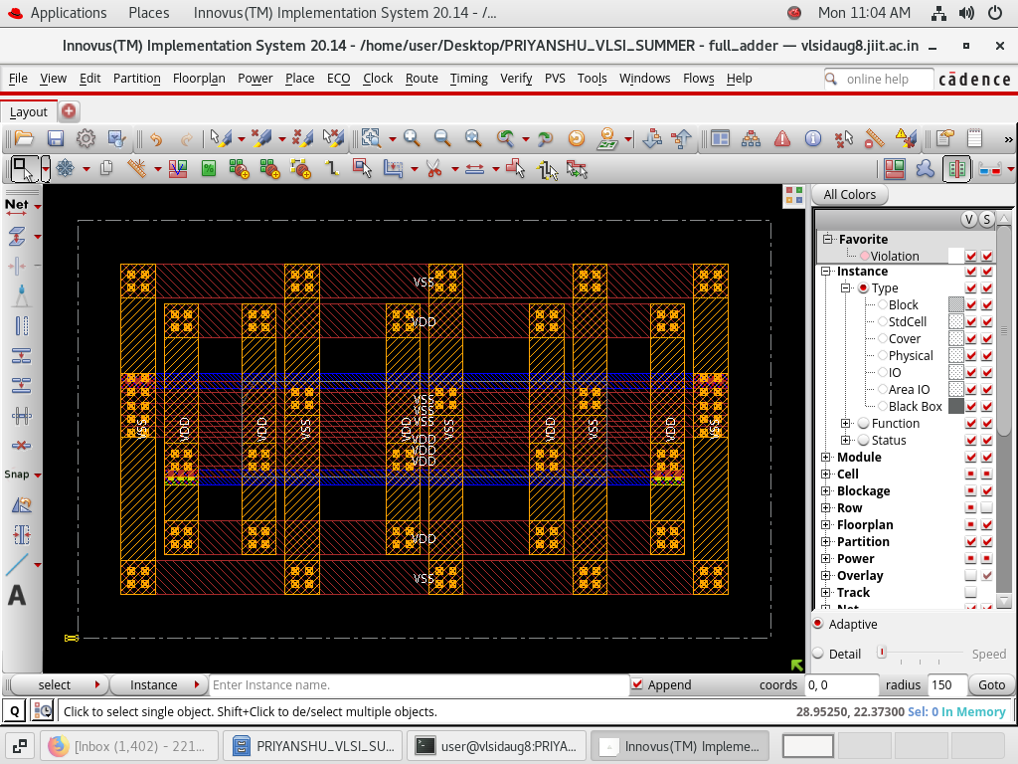
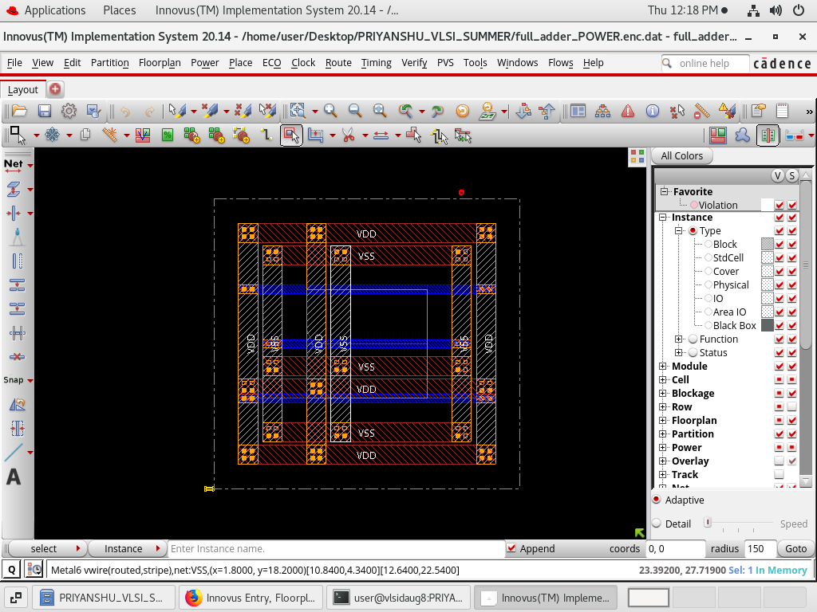

Sequential Circuit – Traffic Light Control
